This assignment is designed to test your understanding of inheritance in Java. The key concepts are interfaces, abstract classes, and writing inheritance hierarchies.
Scenario:  The scenario for this assignment is as follows: Microstuff's attempt to dominate the world through its refrigerator program failed miserably. People were uninterested in it because of its boring GUI, and they were confused because all their food had big question marks on it. Microstuff has instead decided to use the unorthodox marketing strategy of strapping free copies of its web browser, Internet Exploiter, to the backs of sewer rats. As these rats walk through the city sewers, they will spread the software through town. However, Microstuff wants to know what is the best way to train the rats in order to cause the fastest spreading of their software. They have asked your team to write a program that models the city sewer and its rats so they can study it to find the best rat behavior to use.  Each sewer maze has a start and a finish. The start is where the different rats will begin, and the finish is where each rat is trying to reach in order to end the simulation. There will always be a path from the start to the end of every maze.  Your task is to add to Microstuff's provided existing code; you are to write a set of classes to model four (or five) different types of rats. All of your classes you write will belong to the ratrace.rats package. Your classes will belong to an inheritance tree; you will write class Rat as the superclass of all rat types. Your rats must implement the Animal interface. | 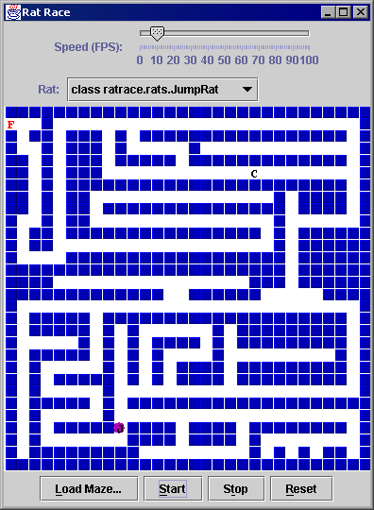

Several pieces of this program have already been written by other Microstuff employees.
- RatRaceGUI.java (class ratrace.gui.RatRaceGUI; the graphical interface)
- Maze.java (class ratrace.Maze; represents the sewer maze)
- Animal.java (interface ratrace.Animal; the interface your rats must implement)
- maze*.maz (text files with diagrams of the city's sewer mazes; used by the GUI)

The following is a list of the public, nonstatic methods in the Animal interface, and therefore, which your Rat class must include:

public <constructor>(int startRow, int startCol)
Constructs a new rat whose position, as well as starting position, is defined by the two given integers. All Rat subclasses must have a constructor with this signature in order for the GUI to work!

public int getColumn()
returns current column animal is in

public char getLetter()
returns one letter to represent animal

public String getName()
returns animal's name

public int getNumMoves()
returns # moves animal has made in maze so far

public int getRow()
returns current row animal is in

public int getStartColumn()
returns column where animal started in maze

public int getStartRow()
returns row where animal started in maze

public void move(Maze maz)
asks animal to make one single move in this maze (as defined for each rat on next page)

public void reset()
moves animal back to starting row/column, wipes # moves to 0

Hints: Note that some of the Animal interface methods are likely implemented the same way for all rat subclasses, while others (such as move) are implemented in completely different ways depending on which subclass you are in. Also, it should be illegal to construct instances of class Rat itself; you should only be able to make instances of its subclasses.

Your memo from Microstuff reminds you that you should follow good style guidelines as described in the last project (Deep Freeze), such as encapsulation and access, comments, indentation, spacing, and identifier names, argument checking and exception avoidance.
The following is a list of the four subclasses of Rat which you must write, as well as details about that rat type, including name, letter, and movement behavior (how the rat moves when its move(Maze) method is called):

Rat Class Name | Details
RandomRat | name: "Randy", letter: 'R'  behavior: Randomly picks any direction (up, down, left, right) in which is is legal to move, and moves one square in that direction. A legal move means a move that is not blocked by a wall.
WallHuggerRat | name: "Wally", letter: 'W'  behavior: Walks along its right-side wall until it reaches the exit. This is done as follows:  - Start out facing up.  - Every time you would like to move, check the following choices in order and make the first move among them that is a legal move:  - moving one square in the direction that is 90 degrees to the right (clockwise) from the way the rat is currently facing  - moving one square straight ahead  - moving one square in the direction that is 90 degrees to the left (counter-clockwise) from the way the rat is currently facing  - moving one square backwards (opposite of the way the rat is currently facing)  - Turn to face in the direction you just moved
JumperRat | name: "Jumpy", letter: 'J'  behavior: Hugs the right-side wall like WallHuggerRat, but can jump over single-square walls to reach the exit faster. This is implemented as follows:  - Start out facing up.  - Every time you would like to move, check the following choices in order and make the first move among them that is a legal move:  - moving one square in the direction that is 90 degrees to the right (clockwise) from the way the rat is currently facing  - moving two squares (by "jumping" over a single-square wall) in the direction that is 90 degrees to the right (clockwise) from the way the rat is currently facing  - moving one square straight ahead  - moving two squares (by "jumping" over a single-square wall) straight ahead  - moving one square in the direction that is 90 degrees to the left (counter-clockwise) from the way the rat is currently facing  - moving one square backwards (opposite of the way the rat is currently facing)  - Turn to face in the direction you just moved
custom rat | make up your own rat with its own unique name, letter, and behavior! You will get full credit as long as the behavior is not any of the following:  - completely random  - an exact copy of one of the three above rats  - mistakenly able to move inside of a wall

Hints: A properly implemented WallHuggerRat escapes maze1.maz in 240 moves and maze2.maz in 270 moves. A proper JumperRat escapes maze1.maz in 100 moves and maze2.maz in 239 moves. The moves needed by RandomRat vary because it is random; in fact, it often takes a ridiculously long time to even come close to getting out of the maze.

The Maze class has some fields and methods which may be useful to you in writing your rat classes. Here is a partial list:

Field / Method Name | Description
public static final char FINISH, OPEN, START, WALL | constants to represent items that could be in maze's squares
public boolean contains(int row, int col) | returns whether the given row/column is within the maze or not
public boolean canMove(row, int col) | returns whether it would be legal for a rat to move to the given row/column (e.g. not blocked by a wall)
public int getNumColumns() | returns how many columns are in this maze
public int getNumRows() | returns how many rows are in this maze
public char getSquare(int row, int col) | returns what is occupying the given square in the maze

Once again you must use JBuilder 6 to write your classes. Name your JBuilder project RatRace. Turn in to rotis a folder named 1_LASTNAME_FIRSTNAME that contains only one item: your JBuilder project folder and all of its contents. This includes all of your source code and the project (.jpx) file used to view your project in JBuilder. You may use your late day on this assignment if you so choose. As with all assignments, all work should be done individually.

